23AI2003 –Artificial Intelligence for Web Development Lab
URK23CS5003

Ex. No: 09 | Node.js+MongoDb Event Registration

Aim

To develop a web-based event registration system using Node.js, Express, and MongoDB that allows users to register for events and enables administrators to search registration details using a NoSQL database.

Description

The application allows users to register for events by entering their register number, name, and selecting up to three events through an HTML form. The data is sent to a Node.js server built using Express, where validation is performed to ensure that no more than three events are selected and duplicate registrations are prevented. The validated data is stored in a MongoDB database as documents, where each record contains the register number, name, and selected events. The system also provides an admin search feature that allows retrieval of registration details using a register number. If the record exists, the details are displayed; otherwise, an appropriate message is shown. This experiment demonstrates the use of a NoSQL database, document-based data storage, backend processing, validation, and data retrieval using Node.js and MongoDB.

Code
Index.html
<!DOCTYPE html>
<html>
<head>
<title>Event Registration</title>
</head>
<body>
<h2>Event Registration Form</h2>

<form action="/register" method="POST">

Register Number:
<input type="text" name="regno" required><br><br>

Name:
<input type="text" name="name" required><br><br>

Select Events (Max 3):<br>

<input type="checkbox" name="events" value="Coding Challenge"> Coding Challenge<br>
<input type="checkbox" name="events" value="Debugging Contest"> Debugging Contest<br>
<input type="checkbox" name="events" value="Web Design"> Web Design<br>
<input type="checkbox" name="events" value="Quiz Competition"> Quiz Competition<br>
<input type="checkbox" name="events" value="Paper Presentation"> Paper Presentation<br><br>

<button type="submit">Register</button>

</form>

</body>
</html>

Search.html

<!DOCTYPE html>
<html>
<head>
<title>Admin Search</title>
</head>
<body>

<h2>Search Registration</h2>

<form action="/search" method="POST">
Enter Register Number:
<input type="text" name="regno" required>
<button type="submit">Search</button>
</form>

</body>
</html>

Server.js

const express = require('express');
const bodyParser = require('body-parser');
const { MongoClient } = require('mongodb');
const path = require('path');

const app = express();
const port = 3000;

app.use(bodyParser.urlencoded({ extended: true }));

// MongoDB URL
const url = "mongodb://localhost:27017";
const client = new MongoClient(url);

const dbName = "eventdb";

// Connect to MongoDB
async function connectDB() {
try {
await client.connect();
console.log("Connected to MongoDB");
} catch (err) {
console.error("Error connecting to MongoDB:", err);
}
}
connectDB();

// ---------------- ROUTES ---------------- //

// Home route
app.get('/', (req, res) => {
res.send("Server + MongoDB Connected!");
});

// Show registration form
app.get('/form', (req, res) => {
res.sendFile(__dirname + '/index.html');
});

// Handle registration
app.post('/register', async (req, res) => {
const { regno, name, events } = req.body;

const db = client.db(dbName);
const collection = db.collection("registrations");

let eventList = events;

// Convert to array
if (!Array.isArray(eventList)) {
eventList = [eventList];
}

// Max 3 validation
if (eventList.length > 3) {
return res.send("Error: You can select maximum 3 events only.");
}

// Duplicate check
const existing = await collection.findOne({ regno: regno });
if (existing) {
return res.send("Error: Register number already exists.");
}

// Insert data
await collection.insertOne({
regno: regno,
name: name,
events: eventList
});

res.send("Registration successful!");
});

// Show admin search page
app.get('/search', (req, res) => {
res.sendFile(__dirname + '/search.html');
});

// Handle search
app.post('/search', async (req, res) => {
const regno = req.body.regno;

const db = client.db(dbName);
const collection = db.collection("registrations");

const result = await collection.findOne({ regno: regno });

if (!result) {
return res.send("No record found");
}

res.send(`
<h2>Registration Details</h2>
Register Number: ${result.regno} <br>
Name: ${result.name} <br>
Events: ${result.events.join(", ")}
`);
});

// ---------------- START SERVER ---------------- //

app.listen(port, () => {
console.log(`Server running at http://localhost:${port}`);
});

Input & Output
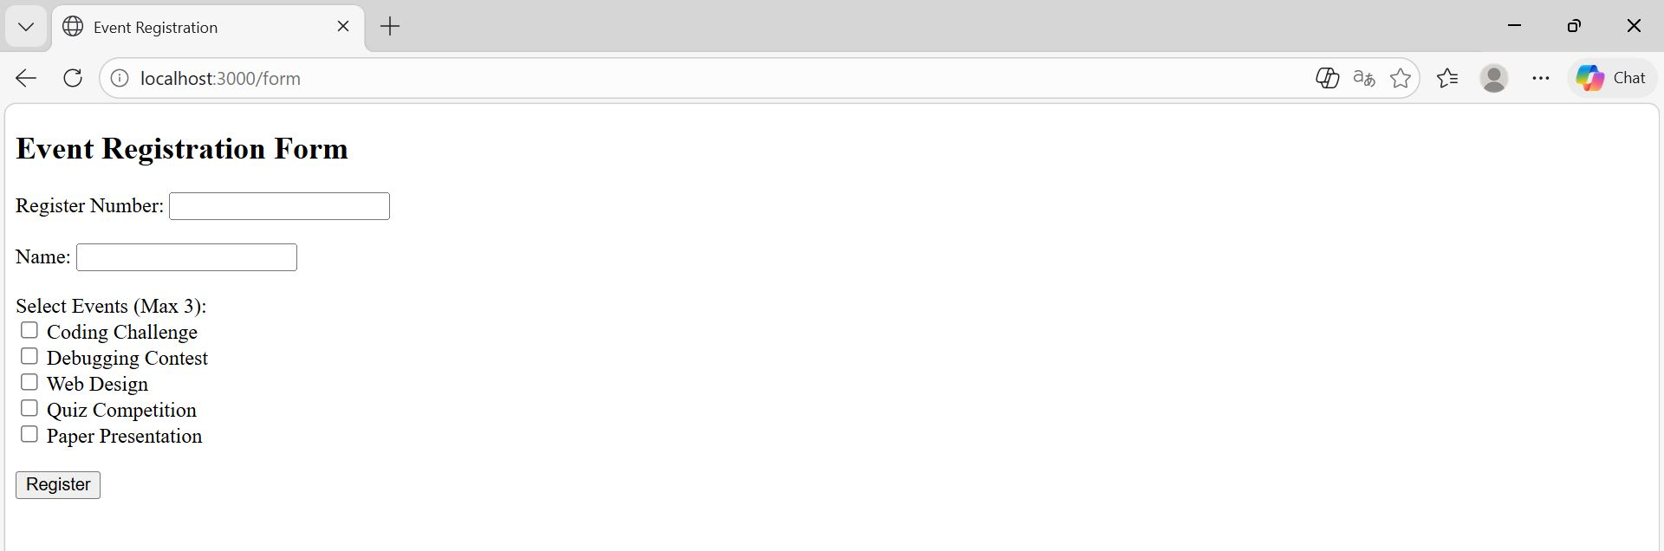

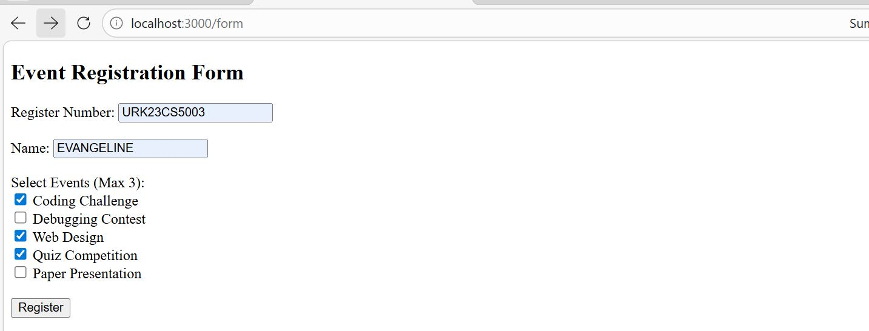

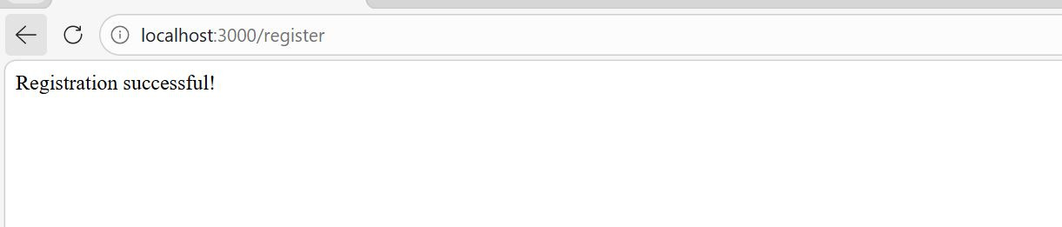

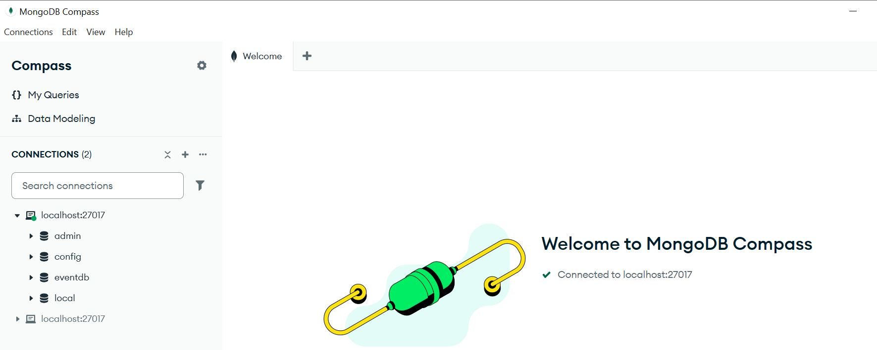
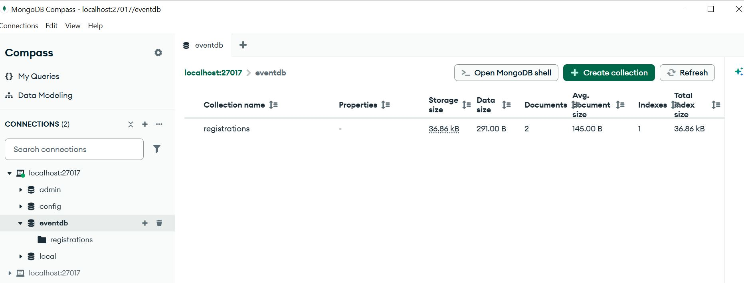
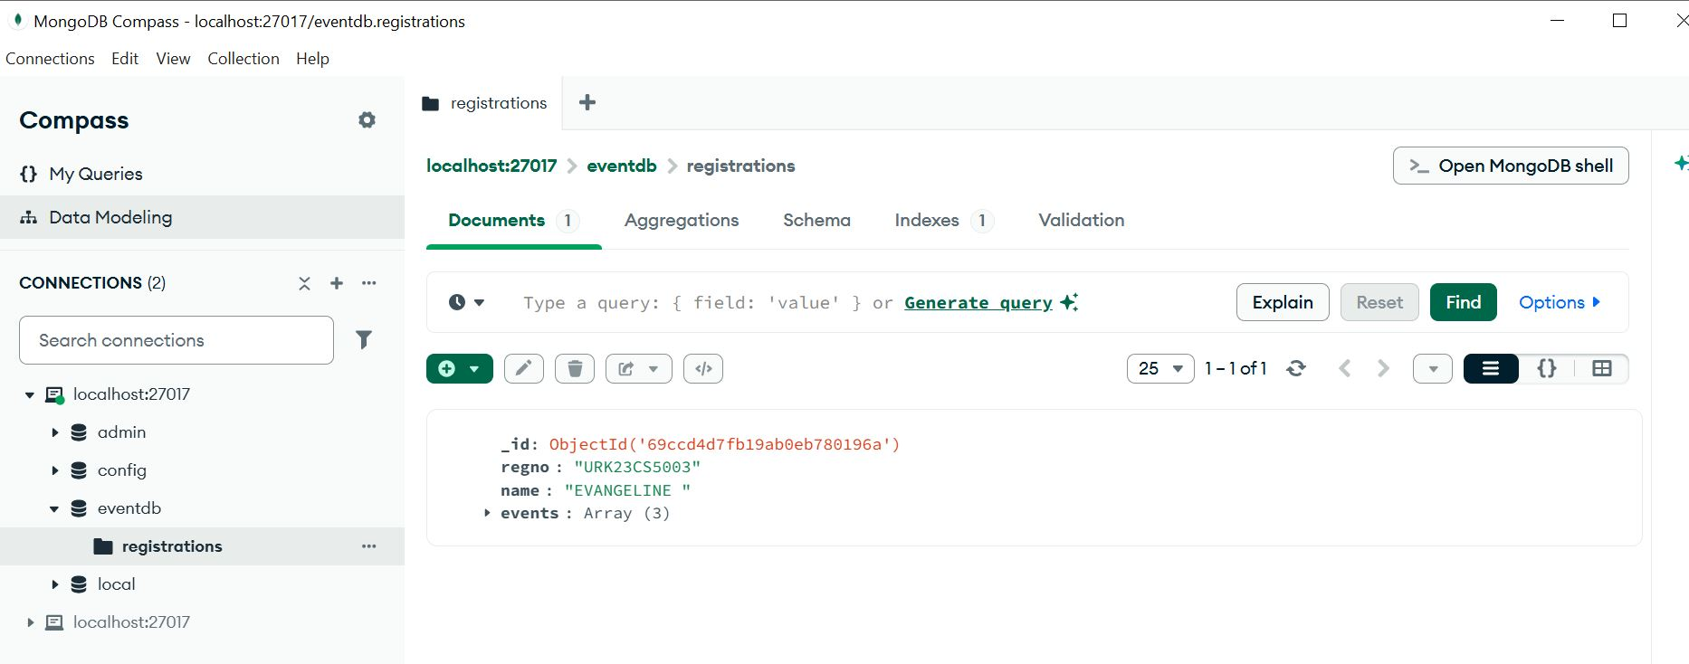

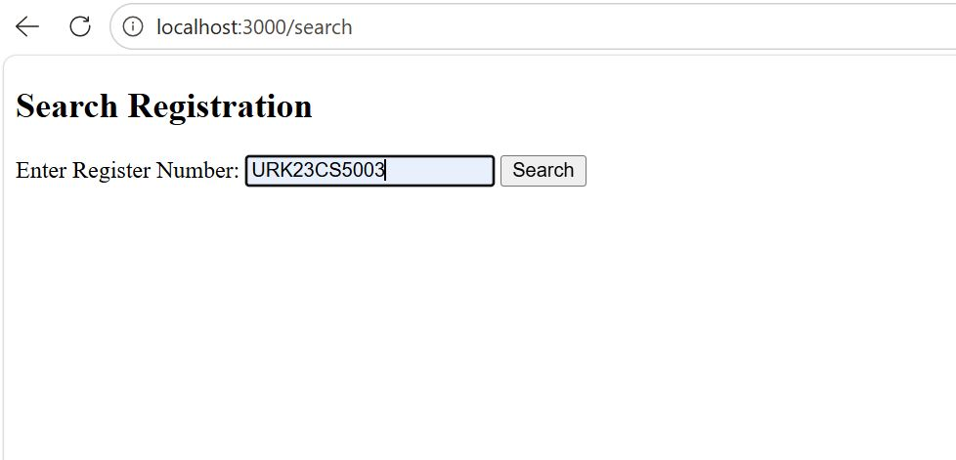
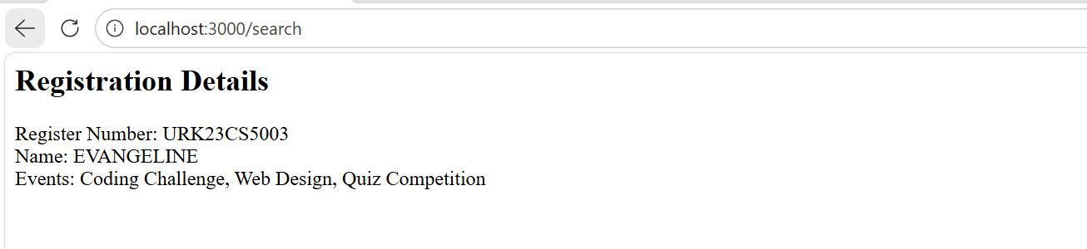

Result
The experiment was successfully completed.

